Contact Kurt at kurtspiegel@hotmail.com to:
- Ask any follow up questions
- Report a new solution that can be added to the list
- Interest in becoming a FSHD Pain Analyst

Recommended reading: Chronic Pain Reset by Afton L. Hassett, PsyD

Online resource to make your own cannabis salve: https://www.mofga.org/resources/cannabis/how-to-make-cannabis-salves/

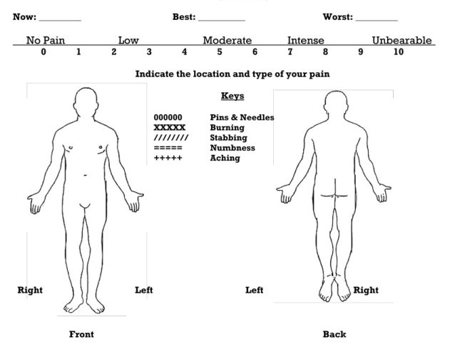

Pain reduction strategies:
The pain will not go away, but by focusing on a treatment that works for you, it can be reduced. Start with a single treatment and monitor its effects. In choosing a treatment we also should minimize risk of side effects, weigh the treatment cost , and consider the availability of treatment.

For each treatment, give it enough time as immediate gratification seems to unavailable. Monitor how you feel to truly understand the long term effects.

Anti-Inflammatory Diet – Eating habits that reduce sugary beverages, refined carbs, and processed foods and adding whole grains and fruits and increasing the intake of fiber.

Alcohol – Research does not offer consistent suggestions on using adult beverages, so common sense should be used. Moderation is a no-brainier, but pay attention to the effects to the pain mitigation on a realistic longer term. Monitor for differences in pain levels, quality sleep, and digestion. Avoid low quality spirits as they are often filled with artificial flavors, colors, and adjuncts.

Arthritis medication – Topical use of Voltaren (Diclofenac Sodium) is a NSAID designed to relieve pain from the pain of arthritis. Another widely available NSAID is ibuprofen, but extended use can create stomach issues.

Hot Springs – Soaking in a hot spring blocks pain receptors as well as reduces inflammation. Hot tubs can provide similar benefits, but the harsh chemicals may irritate skin.

Massage – Most people enjoy a good massage, but as FSHD patients care should be taken by the masseuse to realize some muscles may be missing or easily overworked.

Trigger Point Therapy – If muscles become cramped and knotted, this therapy can quickly resolve the pain. While very painful to receive this therapy, it is short lived and the benefits tend to last.

Physical Therapy – Finding a therapist that is familiar with FSHD is very difficult. An informed PT professional will be able to work stressed muscles and also reduce nerve inflammation.

Transcutaneous electrical nerve stimulation (TENS) – Electrical stimulation through patches applied to skin. This form of massage can be self administered or done by chiropractors or acupuncturists. It should not be applied to damaged or atrophied muscles.

Red Light Therapy – With red light therapy, you expose your skin to a lamp, device, or laser with a red light. A part of your cells called mitochondria, sometimes called the “power generators” of your cells, soak it up and make more energy. Some experts think this helps cells repair themselves and become healthier. This spurs healing in skin and muscle tissue.

Marijuana – Purchasing or preparing a salve using marijuana that contains CDB and possibly THC and applied topically. Using cannabis locally does not produce its psychoactive or intoxicating effects through local application. Topical application will also not produce a positive drug test since it does not enter the blood stream.

Smoking a Indica strain usually produces a calming effect and can help with anxiety, inflammation, muscle stiffness, and nerve-related pain. Smoking is an irritant to eyes, nose, lungs.

Consuming edibles will also help with anxiety, inflammation, muscle stiffness, and nerve-related pain. Easy to ingest, but takes hours before the effects kick in and easy to consume too much.

Acupuncture – Commonly used to treat pain using very thin needles through the skin. It stimulates nerves, muscles, and connective tissue and is believed to boost our bodies natural painkillers.
Research found acupuncture can stimulate the nervous system, releasing endorphins that may help with pain. Insurance coverage varies as many companies do not support this therapy.

Chiropractor – Spinal manipulation can help with musculoskeletal related pains. It may take a few visits before making a determination on effectiveness. Insurance coverage varies, so a bit of research may be necessary before seeking treatment.

Doctor Prescribed Medication – Pain medication, Muscle relaxers, Nerve blockers. These drugs are part of the pharma offerings available from your doctor. Most have side effects so it is important to weigh the risk/reward and closely monitor the effects. Depending on insurance these options may be quite affordable. Many doctors will prescribe pain medication designed to reduce central nervous system pain which is not going to help FSHD patients.

Qigong - Qigong has both psychological and physical components and involves the regulation of the mind, breath, and body’s movement and posture.

Paced breathing – exercises used in yoga use paced breathing and will help with pain and depression. Decreases revving sympathetic activity. Increases calming parasympathetic activity

Mindfulness/Meditation – Mindfulness is your ability to stay in the present, fully aware of where you are and what you are doing and with whom. In a mindful state, you don’t feel overwhelmed by what’s happening around you. Meditation and mental exercises can teach how to calm yourself.
- Cognitive-behavioral therapy to help reduce suffering by thinking differently about pain and how to cope with it.
- Consider addressing the stress in your life as a priority. We can decrease our stress by mindful-based stress reduction (MBSR). In MBSR you consider pain from a distance with interest, not dread.
- Re-frame negative thoughts
  - identify and change unhelpful thoughts
  - focus on making your pain a little better everyday
  - do not let your pain dominate you
- Social support is a key factor for living with pain and disability, yet only about half of people with chronic pain report having strong social support. Build new friendships and strengthen those you value most.
- Guided Imagery – Go to your happy place
  - imagery in your mind, view positive pictures, aroma therapy, take in the splendor of nature
- Healthy Sleep Habits
- Pleasant Activity Scheduling – make time in your day for an enjoyable activity
- Music is emotional medicine and can promote positive emotions
- Social Connections – remove isolation by establishing emotional connections

